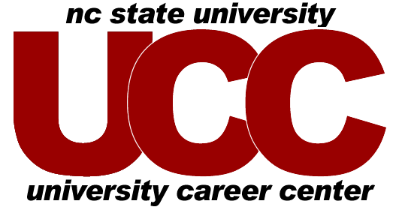

SAMPLE INTERNSHIP #2
Public Policy Intern – MS Society (Eastern NC Chapter)

Job Description

The mission of the National Multiple Sclerosis Society is to end the devastating effects of Multiple Sclerosis. Founded in 1946, the society supports more MS research, offers more services for people with MS, provides more professional education programs and furthers more MS advocacy efforts than any other organization in the world. The Eastern North Carolina Chapter represents an estimated 4,300 people with MS, their families, care partners and health care professionals.

Governmental Relations Responsibilities:
- Assist in matching constituents with MS to legislators on key committees.
- Assist Director in keeping public officials aware of issues that affect their constituents.
- Coordinate and submit written statements to legislators as approved by Governmental Relations Committee (GRC) and Director.
- Attend pertinent committee meetings, public hearings, and coalition meetings as assigned.
- Track legislation related to National MS Society (NMSS) priorities.
- Assist Director in coordinating response campaign (arrange meetings, draft press releases.)
- Assist in moderating and posting to MS Policy Blog.
- Assist in developing weekly legislative updates to NC Chapters.
- Arrange Governmental Relations conference calls and meetings.

Public Education Responsibilities:
- Interact with local advocacy leaders to develop collaborative relationships.
- Assist clients and Self-Help Groups to become MS Activists.
- Attend local advocacy committees as needed, including the Durham Mayor’s Committee.
- Draft articles on advocacy issues and client involvement for the MS Connection newsletter.
- Assist in planning Advocacy day and MS Awareness Day in Raleigh.
- Recruit advocacy volunteers by attending such local MS Society events as MS Walk, WAMS, Dinner of Champions, etc.
Qualifications

Student with major coursework in Public Policy, Political Science, Public Administration, Nonprofit Management or Social Work is preferred.

---------------------------------------------------------------------

Follow job posting hints in ePACK provided by UCC staff
to help succeed with your internship posting.

Updated 2009

